1. JUnit_Basic Testing Exercises

**Exercise 1: Setting Up JUnit**

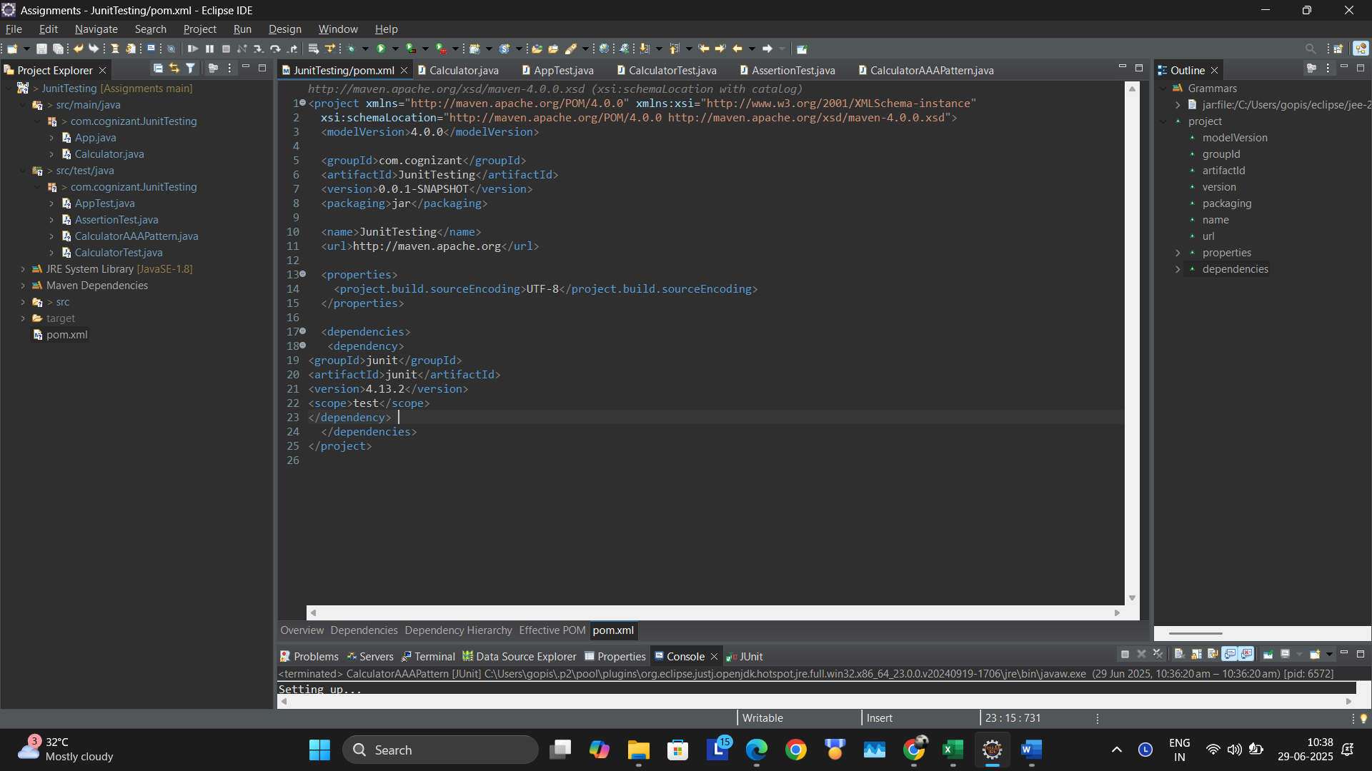

**Exercise 2: Writing Basic JUnit Tests**

**Code:**

**package com.cognizant.JunitTesting;**

**public class Calculator {**

**public int add(int a, int b) {**

**return a + b;**

**}**

**public int subtract(int a, int b) {**

**return a - b;**

**}**

**public int multiply(int a, int b) {**

**return a * b;**

**}**

**public int divide(int a, int b) {**

**if (b == 0) throw new IllegalArgumentException("Cannot divide by zero");**

**return a / b;**

**}**

**}**

**CalculatorTest.java**

package com.cognizant.JunitTesting;

import org.junit.Test;

import static org.junit.Assert.*;

public class CalculatorTest {

*@Test*

public void testAdd() {

Calculator calc = new Calculator();

*assertEquals*(5, calc.add(2, 3));

}

*@Test*

public void testSubtract() {

Calculator calc = new Calculator();

*assertEquals*(1, calc.subtract(4, 3));

}

*@Test*

public void testMultiply() {

Calculator calc = new Calculator();

*assertEquals*(6, calc.multiply(2, 3));

}

*@Test*

public void testDivide() {

Calculator calc = new Calculator();

*assertEquals*(2, calc.divide(6, 3));

}

*@Test*(expected = IllegalArgumentException.class)

public void testDivideByZero() {

Calculator calc = new Calculator();

calc.divide(6, 0);

}

}

Output:

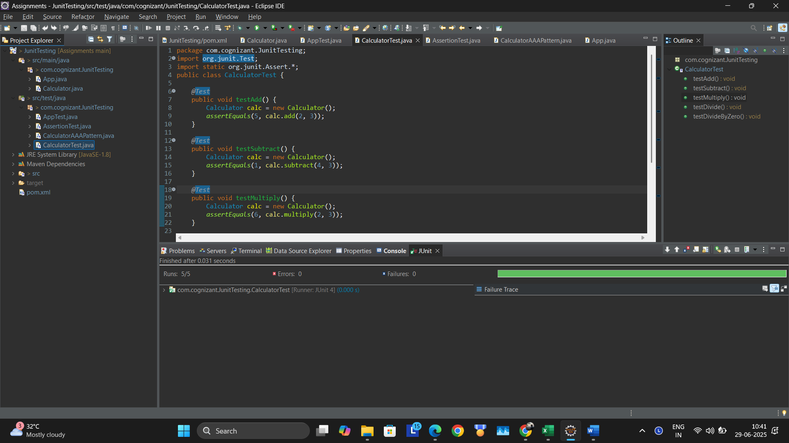

**Exercise 3: Assertions in Junit**

package com.cognizant.JunitTesting;

import org.junit.Test;

import static org.junit.Assert.*;

public class AssertionTest {

*@Test*

public void testAssertions() {

*assertEquals*(5, 2 + 3);

*assertTrue*(5 > 3);

*assertFalse*(5 < 3);

*assertNull*(null);

*assertNotNull*(new Object());

}

}

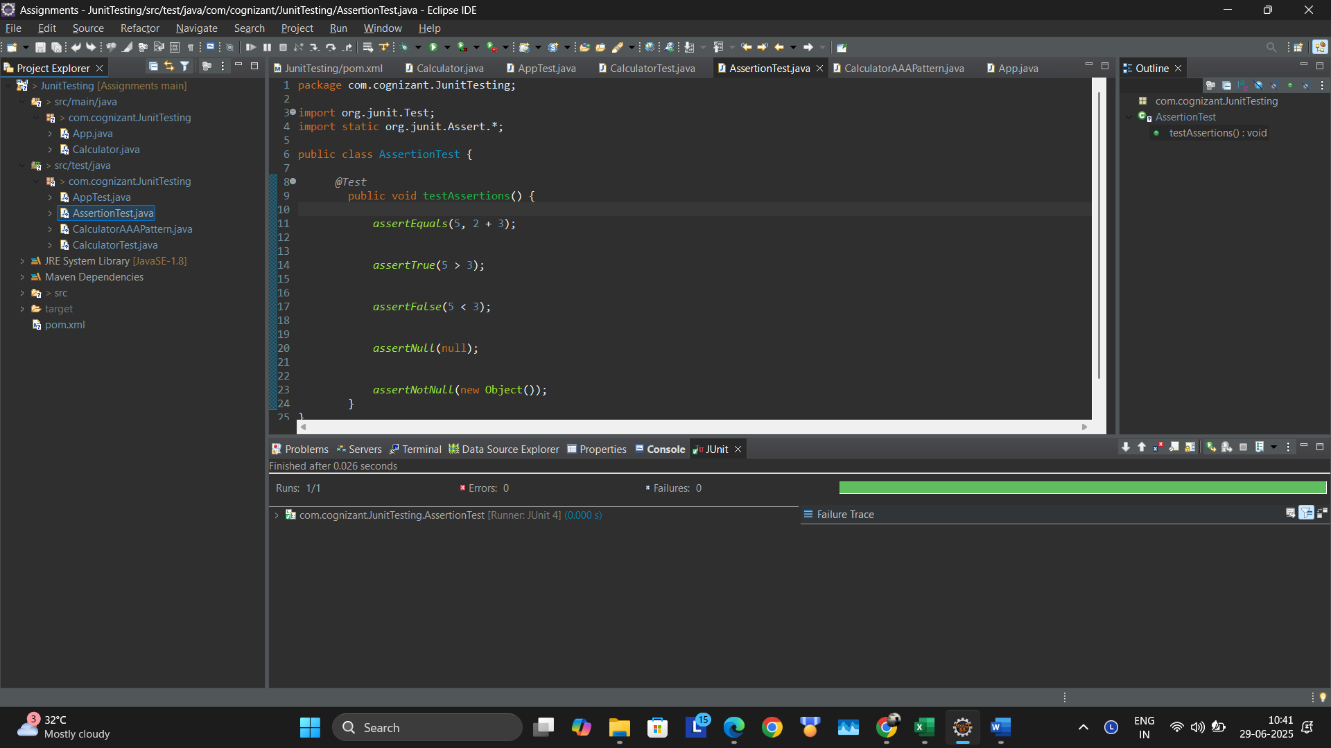

**Exercise 4: Arrange-Act-Assert (AAA) Pattern, Test Fixtures, Setup and Teardown Methods in Junit**

package com.cognizant.JunitTesting;

import org.junit.After;

import org.junit.Before;

import org.junit.Test;

import static org.junit.Assert.*;

public class CalculatorAAAPattern {

private Calculator calculator;

*@Before*

public void setUp() {

calculator = new Calculator();

System.***out***.println("Setting up...");

}

*@After*

public void tearDown() {

calculator = null;

System.***out***.println("Cleaning up...");

}

*@Test*

public void testAdd_AAA() {

int result = calculator.add(10, 20);

*assertEquals*(30, result);

}

*@Test*

public void testSubtract_AAA() {

int result = calculator.subtract(30, 10);

*assertEquals*(20, result);

}

}

Output:

